**Computational Mathematics – Formative Assessment Write-Up**

Data relating to the period of growth from 2017 to 2018

|  |  |  |  |  |  |  |
| --- | --- | --- | --- | --- | --- | --- |
| **Item Number** | **Old Price 2017 (£)** | **New Price 2018 (£)** | **Expected Price**  **2018 (£)** | **Difference**  **(£)** | **Percentage Difference %** | **Overcharged** |
| **2** | 1.01 | 1.03 | 1.04 | -0.01 | -0.74 | Somewhat |
| **3** | 2..00 | 2.10 | 2.06 | 0.04 | 1.78 | Yes |
| **4** | 0.50 | 0.57 | 0.52 | 0.05 | 9.10 | Significantly |
| **5** | 1.24 | 1.28 | 1.28 | 0.00 | 0.08 | No |

Data relating to the period of growth from 2018 to 2019

|  |  |  |  |  |  |  |
| --- | --- | --- | --- | --- | --- | --- |
| **Item Number** | **Old Price 2018 (£)** | **New Price**  **2019 (£)** | **Expected Price**  **2019 (£)** | **Difference**  **(£)** | **Percentage Difference %** | **Overcharged** |
| **2** | 1.03 | 1.07 | 1.06 | 0.01 | 0.74 | Yes |
| **3** | 2.10 | 2.12 | 2.16 | -0.04 | -1.81 | No |
| **4** | 0.57 | 0.53 | 0.58 | -0.05 | -10.02 | No |
| **5** | 1.28 | 1.32 | 1.32 | 0.00 | -0.08 | No |

Data relating to the period of growth from 2017 to 2019

|  |  |  |  |  |  |  |
| --- | --- | --- | --- | --- | --- | --- |
| **Item Number** | **Old Price 2017 (£)** | **New Price**  **2019 (£)** | **Expected Price**  **2019 (£)** | **Difference**  **(£)** | **Percentage Difference %** | **Overcharged** |
| **2** | 1.01 | 1.07 | 1.07 | 0.00 | 0.00 | No |
| **3** | 2.00 | 2.12 | 2.12 | 0.00 | 0.00 | No |
| **4** | 0.50 | 0.53 | 0.53 | 0.00 | 0.00 | No |
| **5** | 1.24 | 1.32 | 1.32 | 0.00 | 0.00 | No |

**Question 6**

1. **[10] If prices of four of the twenty items in 2017 were £1.01, £2.00, £0.50 and £1.24, what should their prices be in 2018 and 2019?**

|  |  |  |  |
| --- | --- | --- | --- |
| **Item Number** | **Price in 2017 (£)** | **Expected Price in 2018 (£)** | **Expected Price in 2019 (£)** |
| **2** | 1.01 | 1.04 | 1.07 |
| **3** | 2.00 | 2.06 | 2.12 |
| **4** | 0.50 | 0.52 | 0.53 |
| **5** | 1.24 | 1.28 | 1.32 |

1. **[20] Establish what the prices charged for each year have been. Can you explain and show what the price discrepancy is?**

|  |  |  |  |  |  |  |
| --- | --- | --- | --- | --- | --- | --- |
| **Item Number** | **Prices Charged in 2018 (£)** | **Difference between expected and actual price in 2018 (£)** | **Percentage Difference**  **2018 %** | **Prices Charged in 2019 (£)** | **Difference between expected and actual price in 2019 (£)** | **Percentage Difference**  **2019 %** |
| **2** | 1.04 | -0.01 | -0.74 | 1.07 | 0.00 | 0.00 |
| **3** | 2.06 | 0.04 | 1.78 | 2.12 | 0.00 | 0.00 |
| **4** | 0.52 | 0.05 | 9.10 | 0.53 | 0.00 | 0.00 |
| **5** | 1.28 | 0.00 | 0.08 | 1.32 | 0.00 | 0.00 |

For more detail please observe the complete statistical tables above. From this we can see that items 3, 4 were overcharged by the supplier in 2018 by 1.78% (£0.04) and 9.10% (0.05) respectively. Item 2 was slightly undercharged in this year by 0.74% (£0.01). The difference in price between the expected and actual price of item 5 in 2018 is negligible. In 2019 however the supplier did manage to charge the client exactly the right amount according to the agreed rate of inflation on their goods.

**iii) [20] Establish what the actual costs each year should be and where has the error occurred? Show your reasoning.**

|  |  |  |  |  |  |  |  |  |  |
| --- | --- | --- | --- | --- | --- | --- | --- | --- | --- |
| **Item Number** | **Price 2017 (£)** | **Price**  **2018 (£)** | **Expected Price**  **2018 (£)** | **Difference in Price**  **2018 (£)** | **Percentage Difference 2018 %** | **Price**  **2019 (£)** | **Expected Price**  **2019 (£)** | **Difference in Price**  **2019 (£)** | **Percentage Difference 2019 %** |
| **2** | 1.01 | 1.03 | 1.04 | -0.01 | -0.74 | 1.07 | 1.07 | 0.00 | 0.00 |
| **3** | 2..00 | 2.10 | 2.06 | 0.04 | 1.78 | 2.12 | 2.12 | 0.00 | 0.00 |
| **4** | 0.50 | 0.57 | 0.52 | 0.05 | 9.10 | 0.53 | 0.53 | 0.00 | 0.00 |
| **5** | 1.24 | 1.28 | 1.28 | 0.00 | 0.08 | 1.32 | 1.32 | 0.00 | 0.00 |

There is an error with the data from 2018 where some of the items have been overcharged and others undercharged.

**Question 7 -** **Inverse matrix problems, computational limits:**

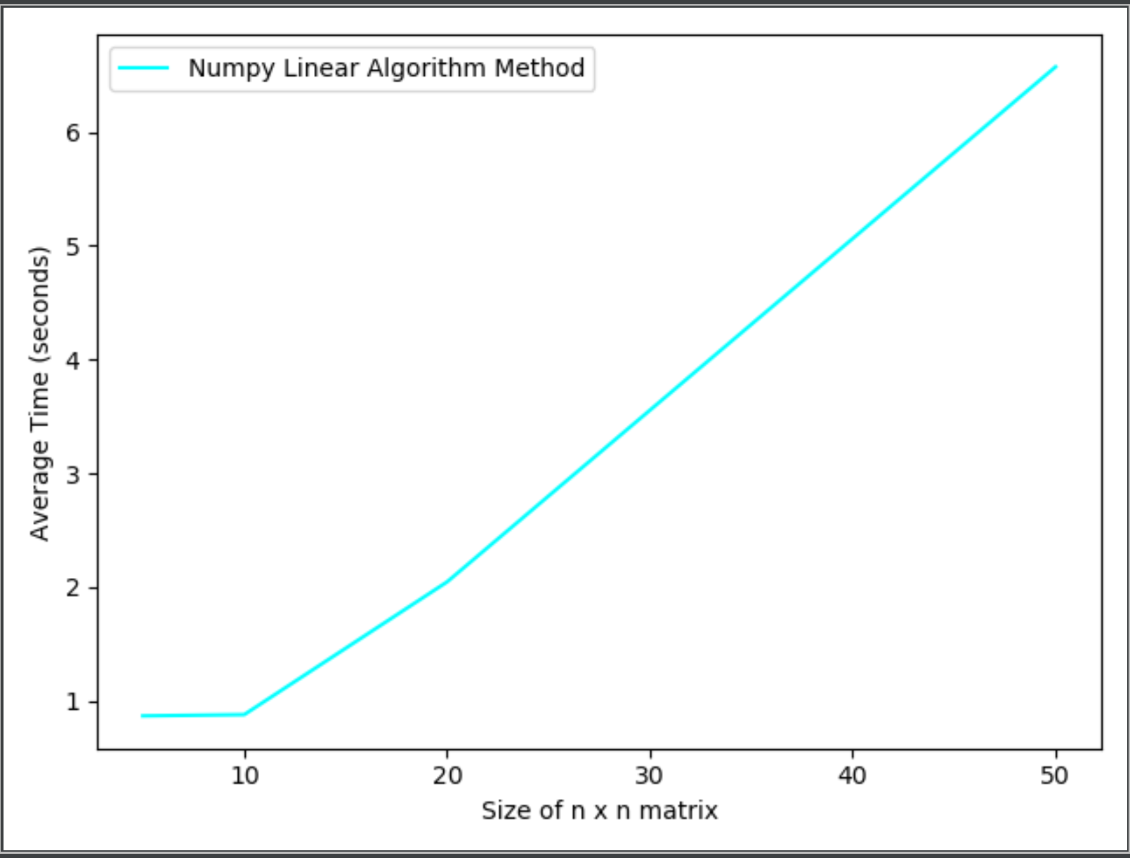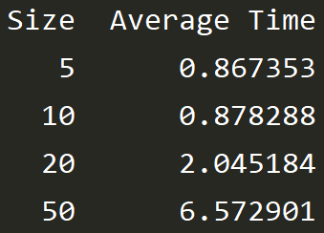

n = [5, 10, 20, 50] Using these values of n the graph shows for 9999 iterations finding the solution to the inverse matrix how time varies with size n x n.

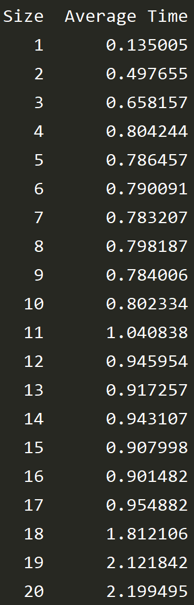

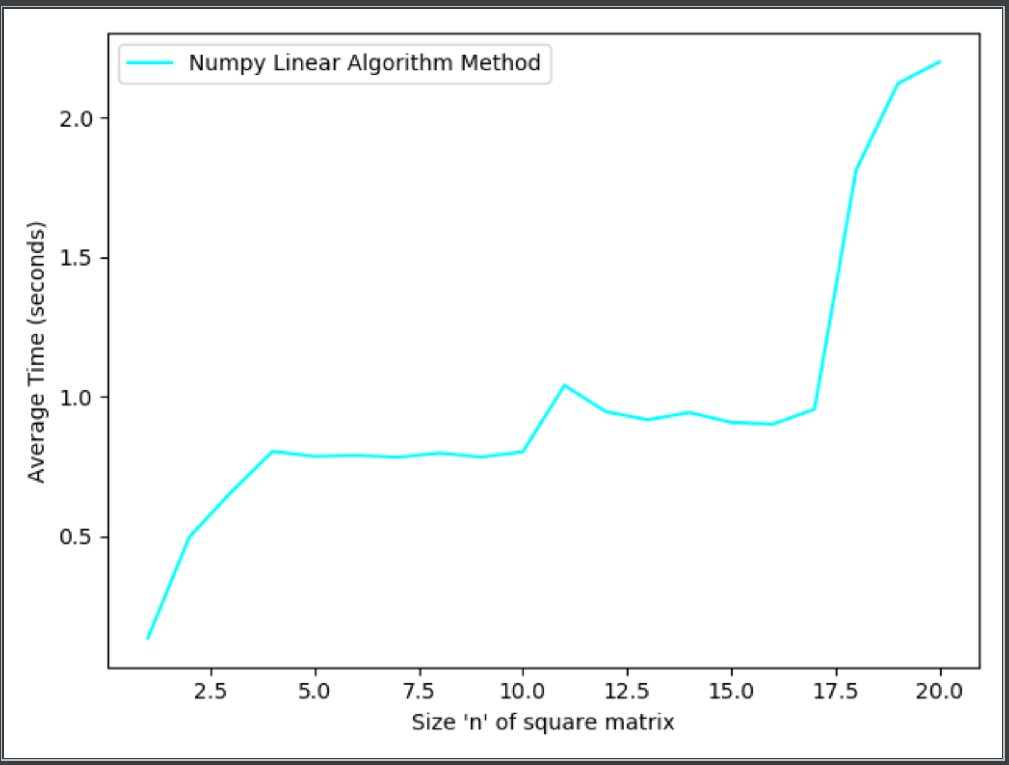

This graph shows the average cumulative time to complete 9999 iterations to solve for the inverse of a matrix and how this varies with the size n of the square matrix. For this example, the value of n was incremented by one each time and five repeats were used to find the average time from 9999 cumulative iterations for each size of matrix.

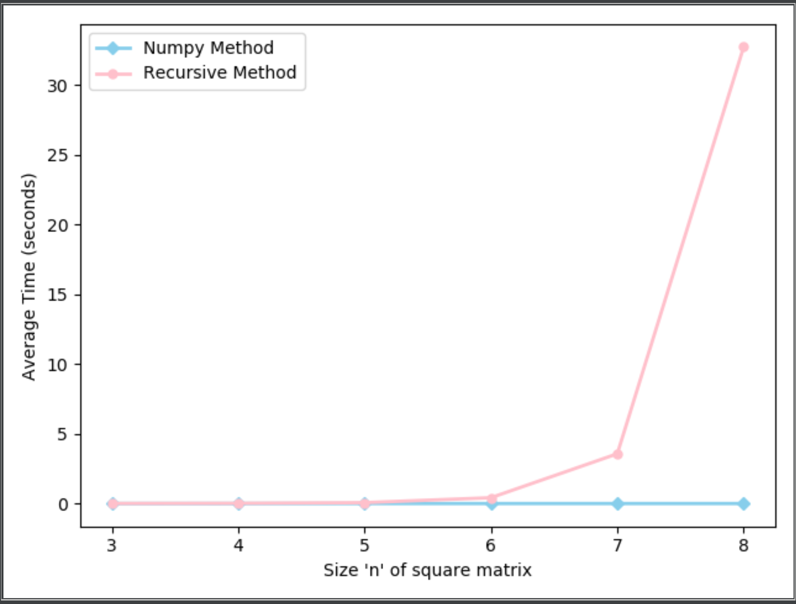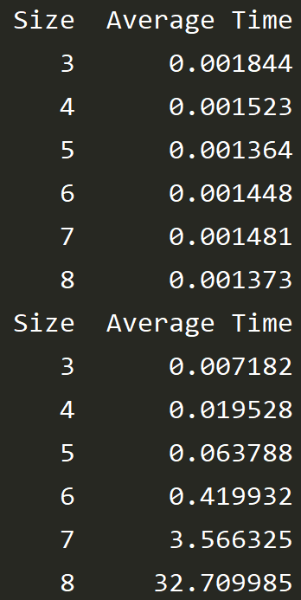

**Numpy linear algorithm inverse method.** The numpy method is far better at finding the inverse especially at larger values of n like the ones shown above.

**Cramer's Recursive Method** The **r**ecursive method is very inefficient for matrices above n = 6 taking over four minutes to solve the inverse for a 9 x 9 square matrix.